**Dynamic Reference Qualifier:**

Dynamic filter options table

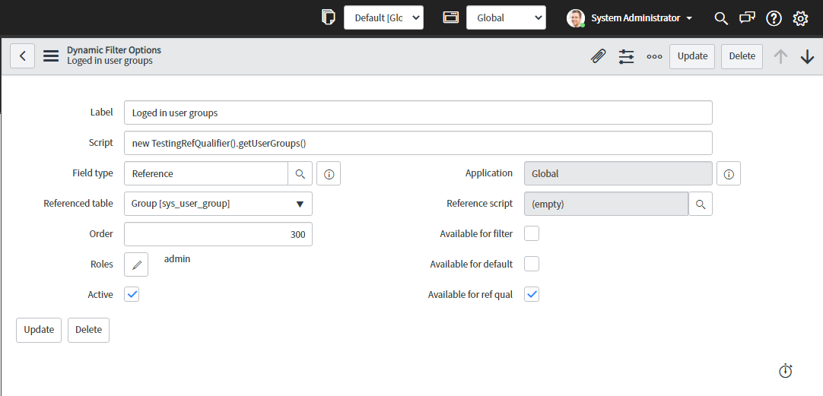

Script Include:

